
INSTUTUTE: MBARARA UNIVERSITY OF SCIENCE AND TECHNOLOGY.
FACULTY OF COMPUTING AND INFORMATICS.
AREA OF INTEREST: REAL ESTATE COMPANY THAT DEALS IN LAND SALES.
NAME: BASEEGA MANGADALENA.
REGISTRATION NUMBER: 2025/BCS/065/PS.
LECTURER: BAGUMA KENETH.
COURSE UNIT: DATABASE SYSTEMS.
COURSE CODE: CSC1204
PROJECT NAME: STAFF MANAGEMENT SYSTEMS.
DATE: MAY 7, 2026.
PROGRAM: BACHELOR OF SCIENCE IN COMPUTER SCIENCE

EXECUTIVE SUMMARY

This report presents a staff management database system for a real estate company that deals in land sales. The company has staff members such as the CEO, director, secretary, accountant, sales agents, heads of department, and administrators. The database was designed and implemented in MariaDB under XAMPP using SQL. It stores staff information, department details, positions, login accounts, attendance records, salary data, and allowances. The system supports efficient storage, retrieval, and reporting of staff data.

BUSINESS CASE:

The real estate company needs a reliable way to manage staff records because manual record keeping is slow, repetitive, and prone to errors. A database system helps the company store staff information in one place, reduce duplication, and generate reports quickly. Since the organization has different staff roles and departments, the system must support role management, attendance tracking, salary processing, and secure login accounts.
Requirements:
The database must store the following information:
Department details.
- Staff positions and salary scales.
- Staff personal and employment details.
- Login account details for authorized users.
- Daily attendance records.
- Salary
- Allowances.
The database must also allow users to add new staff members, update records, search for specific staff, view salary details, and generate summaries.
Benefits
- Improves accuracy of staff records.
- Reduces paperwork and manual errors.
- Speeds up salary and attendance management.
- Makes reporting easier for management.
- Supports secure and organized data storage.
- Correction of errors is easier than when using paper for example it can easily be done by performing queries like update among others.
Costs
- Time spent on design and implementation.
- Need for a computer and XAMPP/MariaDB software.
- Training users to understand the system.
- Maintenance and backup costs.
User Issues
- Some users may not understand SQL commands.
- Incorrect data entry may happen without training.
- Passwords must be protected properly otherwise this can stop the user from accessing the database especially when they forget their password.
- Some users may want reports in a simple format.
Risk Assessment
- Data loss if no backups are made.
- Unauthorized access if login security is weak.
- Wrong salary values if validation is poor.
- Database slow-down if the tables grow without good design.
Limitations
- The system focuses only on staff management.
- It does not manage customer sales fully.
- It does not include advanced HR features such as leave management.
- It assumes the salary structure is already known.
LOGICAL DESIGN
Entities
- Department
- Position
- Staff
- Login_ Account
- Attendance
- Salary
- Allowance
Attributes
- Department: department_ id, department _name, description
- Position: position_ id, position_ name, salary_ scale
- Staff: staff_ id, staff_ name, gender, phone, email, address, hire_ date, status, department_ id, position_ id
- Login_ Account: account_ id, staff_ id, username, password_ hash, role, last_ login
- Attendance: attendance_ id, staff_ id, work_ date, check in, checkout
- Salary: salary_ id, gross_ pay,
- Allowance: allowance_ id, salary_ id, allowance_ type, amount
Relationships
- Department to Staff: one-to-many.
- Position to Staff: one-to-many.
- Staff to Login_ Account: one-to-one.
- Staff to Attendance: one-to-many.
- Staff to Salary: one-to-many.
- Allowance: one-to-many
Multiplicities
- One Department can have many Staff members.
- One Position can be held by many Staff members.
- One Staff member can have one Login_ Account.
- One Staff member can have many Attendance records.
- One Staff member can have many salary records.
- One Salary record can have many Allowances records.

The ERD illustrating the relationships between entities

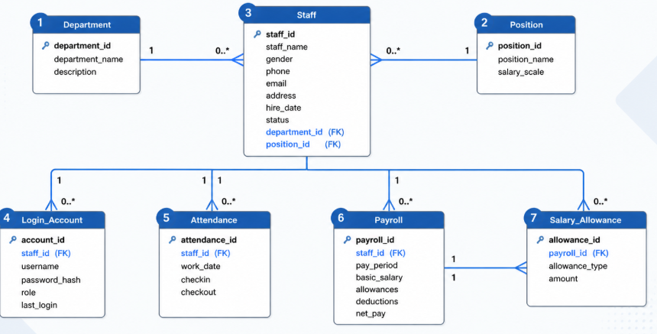

User Interface

The system interface is represented by the MariaDB command line through XAMPP. Users can enter SQL commands such as create table, insert into, select, show tables, describe, update and alter tables. This interface is appropriate because the project focuses on database implementation and testing.
Sample of the user interface:

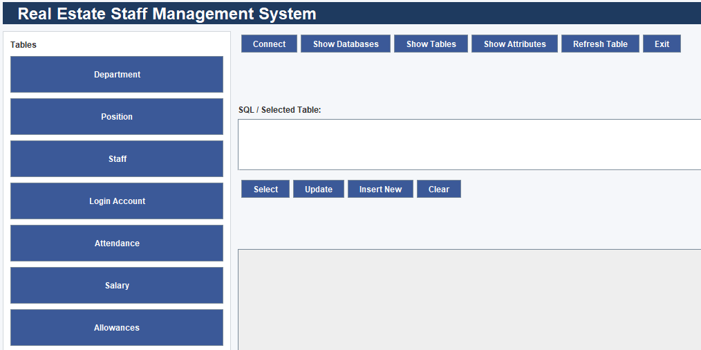

PHYSICAL DESIGN
Database Schema
My database is called staff_ management_ system. It contains the following tables:
- Department
- Position
- Staff
- Login_ Account
- Attendance
- Salary
- Allowance
Table Descriptions
Department stores company departments.
Position stores job titles and salary scales.
Staff stores employee personal and job details.
Login_ Account stores system login information.
Attendance stores daily attendance records.
Salary stores monthly salary records.
Allowance stores extra payment details linked to salary.

PHYSICAL DESIGN
The following SQL code is the physical implementation of the staff management systems which creates tables for the above entities.
Show Databases
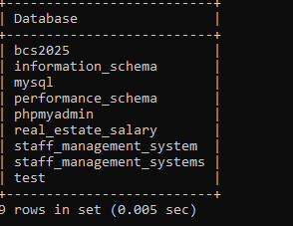
Showing Tables
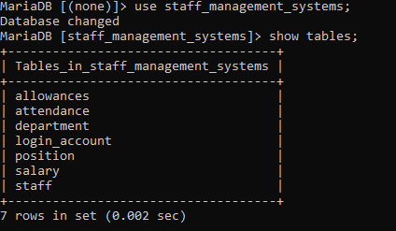
STAFF TABLE
CREATE TABLE Staff (staff_ id INT PRIMARY KEY AUTO_INCREMENT, staff_ name VARCHAR(100), gender VARCHAR(10), email VARCHAR(50), address VARCHAR(50), date_ of_ birth DATE, status VARCHAR(50), hire_ date DATE, phone VARCHAR(50));
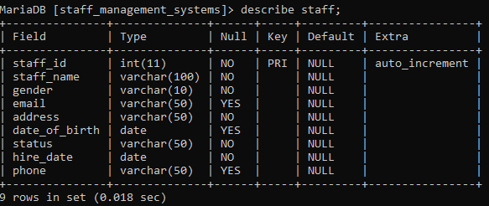
DEPARTMENT TABLE
CREATE TABLE Department (department_ id INT PRIMARY KEY AUTO_INCREMENT, department_ nameVARCHAR(100), descriptionVARCHAR(100));
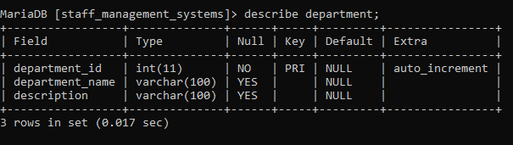
POSITION TABLE
CREATE TABLE Position (position_ id INT PRIMARY KEY AUTO_INCREMENT, position_ name VARCHAR(100), salary_ scale DECIMAL(10,2);
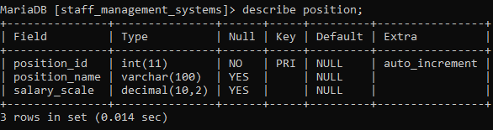
CREATE ATTENDANCE
CREATE TABLE Attendance (attendance_ id INT PRIMARY KEY AUTO_INCREMENT, staff_id INT NOT NULL,workdate DATE, check_ in TIME, check_ out TIME FOREIGN KEY(staff_id) REFERENCES Staff(staff_id) );
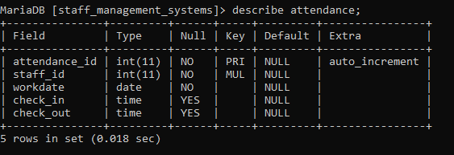
SALARY TABLE
CREATE TABLE Salary (salary_ id INT PRIMARY KEY AUTO_INCREMENT, staff_id INT NOT NULL, pay_ period DATE, gross_ pay DECIMAL(10,2), FOREIG KEY(staff_id) REFERENCES Staff(staff_id) );
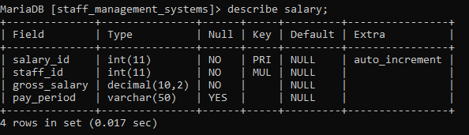
LOGIN_ACCOUNT
CREATE TABLE LOGIN_TABLE( account_ id INT PRIMARY KEY AUTO_INCREMENT, username VARCHAR(50),password_hash VARCHAR(50), role VARCHAR(100), last_ login DATE);
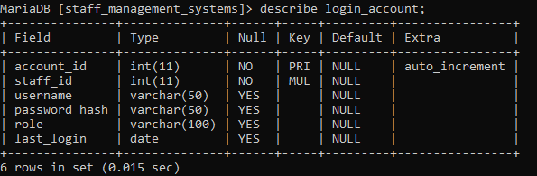
ALLOWANCES TABLE
CREATE TABLE Allowances(allowance_ id INT PRIMARY KEY AUTO_INCREMENT, allowance_ type ENUM(‘meals’, ’housing’, ’transport’), salary_ id INT NOT NULL, amount Decimal(10,2) FOREIGN KEY (salary_id) REFERENCES Salary(salary_id);

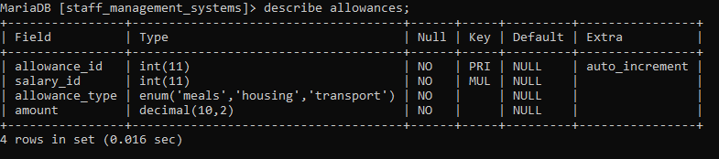

Query and Report Design
The database supports queries that show staff by department, staff by position, attendance records, salary summaries, and allowances. These outputs help management monitor employees, process salaries, and track attendance.
IMPLEMENTATION
The database was implemented in MariaDB under XAMPP. The tables were created using SQL. Sample data was inserted for staff roles such as CEO, director, secretary, accountant, sales agent, head of department, and administrator. Foreign key constraints were used to maintain relationships between tables.
Sample SQL queries include:
IMPLEMENTATION
This includes screenshots of implemented systems, queries and their results.
SELECT * FROM Staff
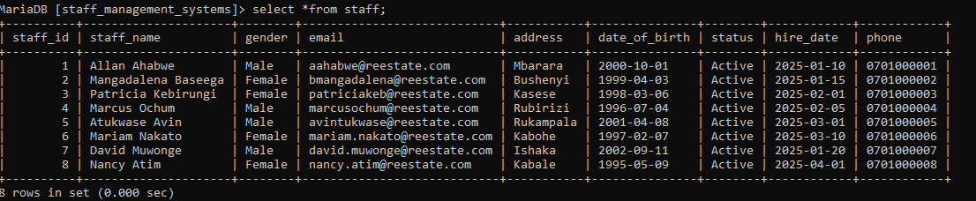
SELECT * FROM Department
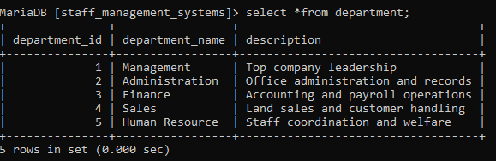
SELECT * FROM Position
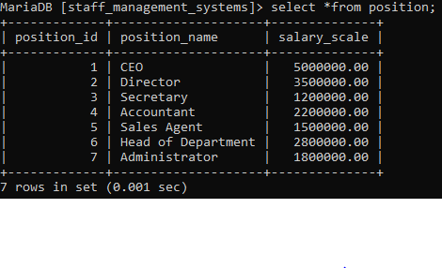
SELECT * FROM Attendance
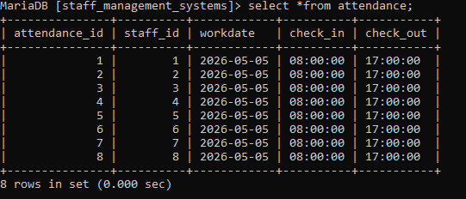
SELECT * FROM Login_account

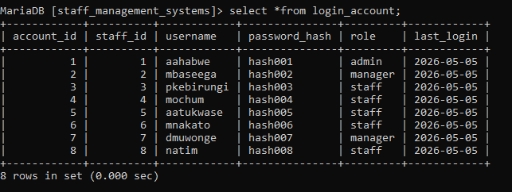
SELECT * FROM Salary

SELECT * FROM Allowances

CONCLUSION
The staff management database provides an organized way to store and manage employee information for the real estate company. It improves efficiency, supports reporting, and reduces errors in manual record keeping. The system meets the needs of the business case by linking departments, positions, staff, attendance, salary, and allowances in one database.

BIBLIOGRAPHY
- MySQL Documentation: https://dev.sql.com/doc/
- Text books: A Practical APPROACH to Design, Implementation ,and Management Sixth edition by Thomas Connolly .Carolyn Begg
-Database design tutorials from W3Schools

